**Responses from Research Questionnaire Feedback Progress So Far**



Forms response chart. Question title: Job Title (Your Current Job Title)
. Number of responses: 33 responses.

Forms response chart. Question title: Years of Experience (How many years of experience do you have in project management or related field)
. Number of responses: 33 responses.

Forms response chart. Question title:  Firm Size
. Number of responses: 33 responses.

Forms response chart. Question title: 1.  Ease of Use
. Number of responses: .

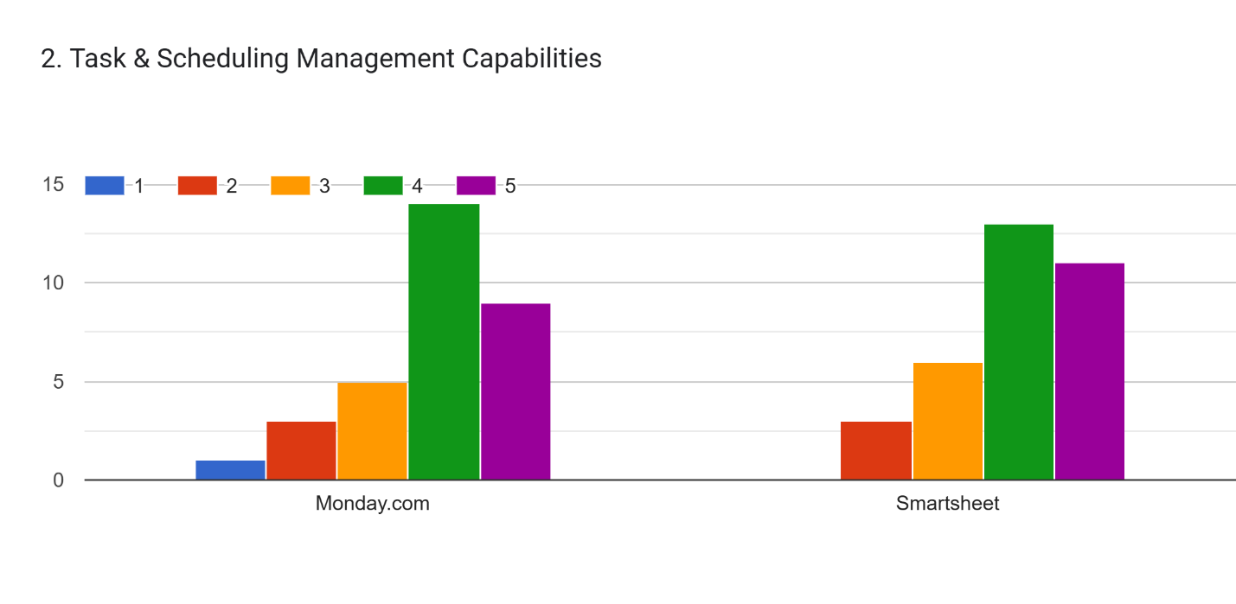

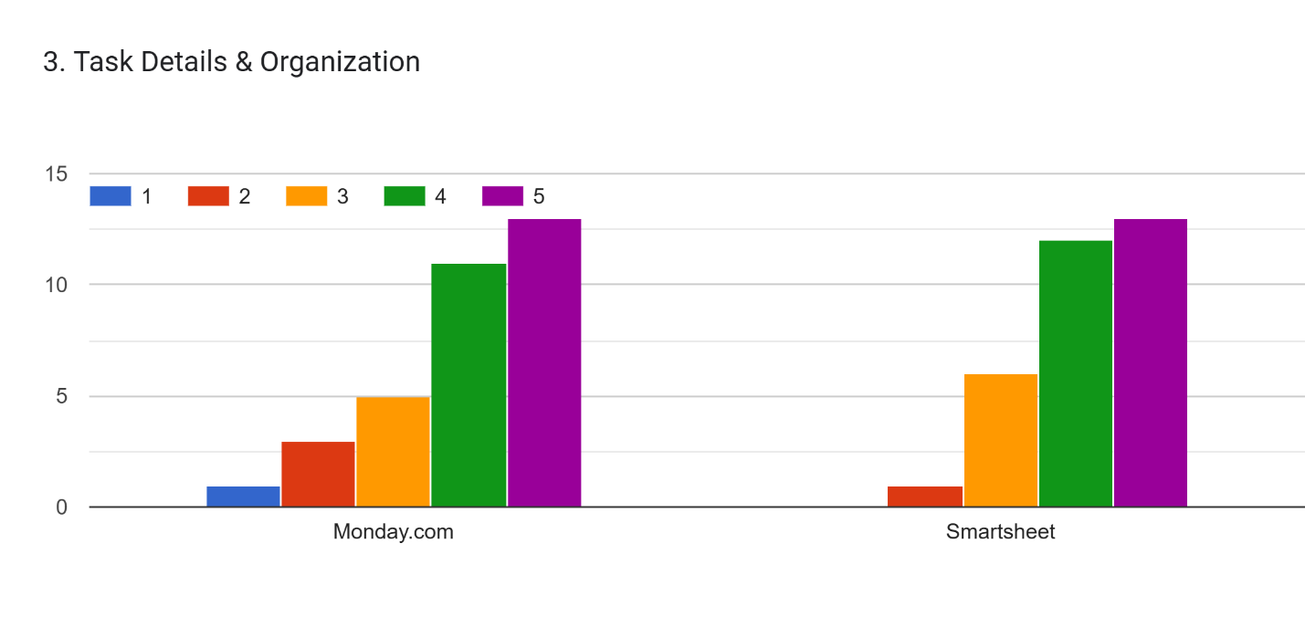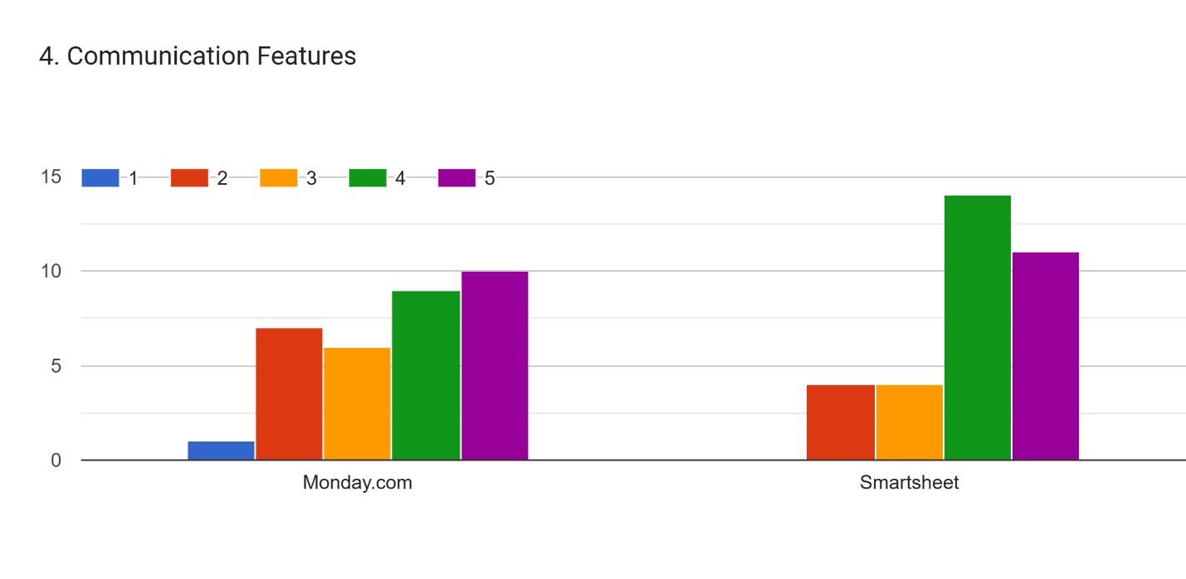

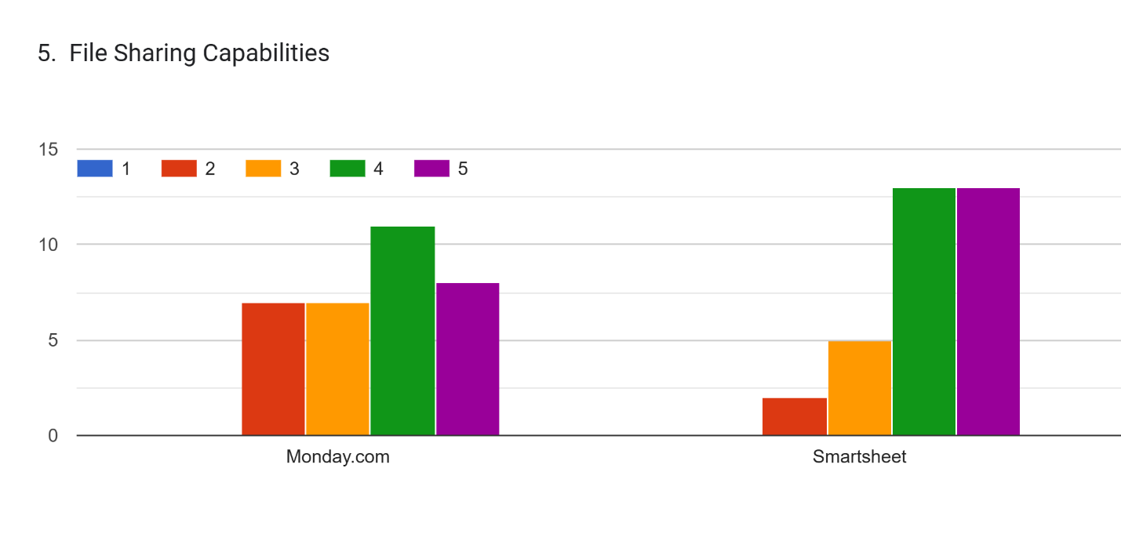

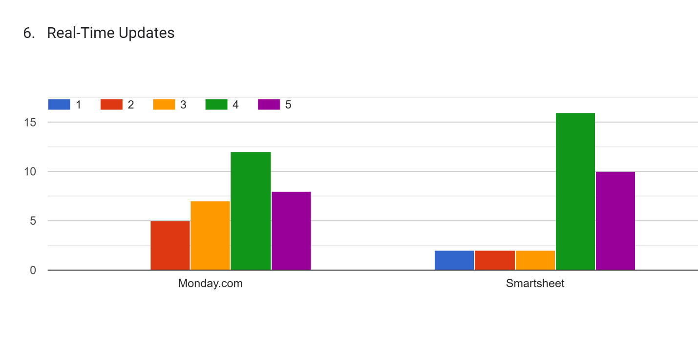

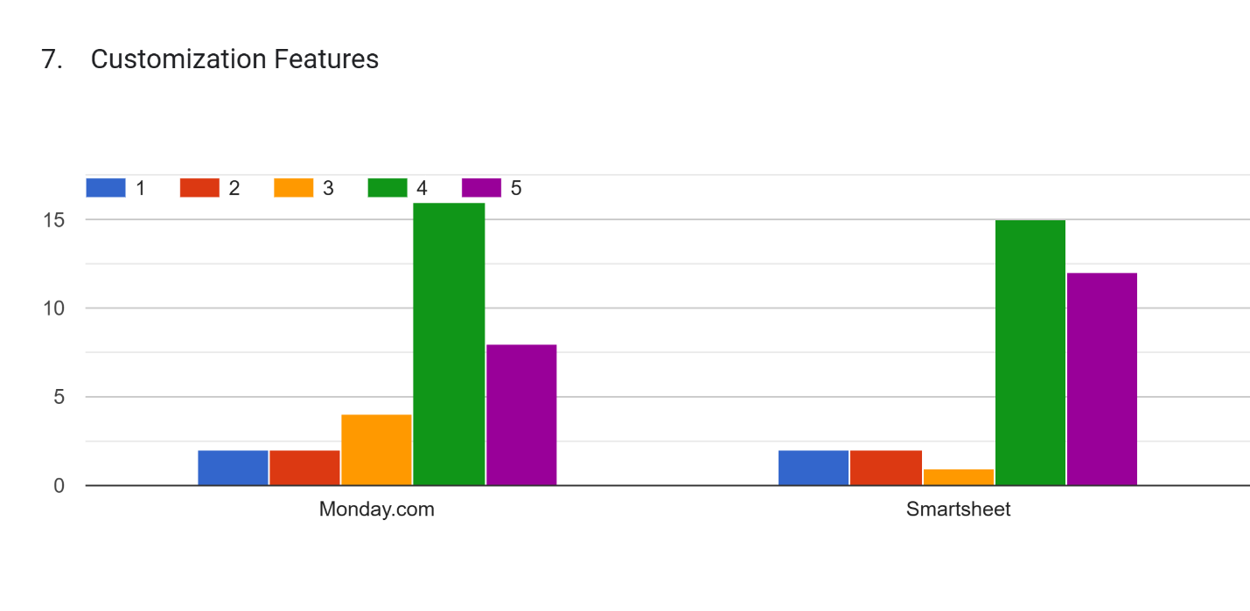

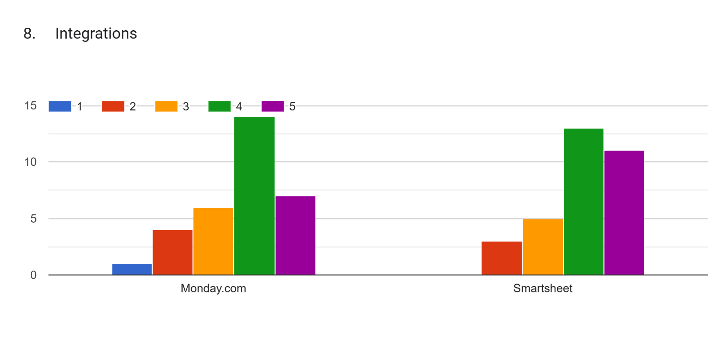

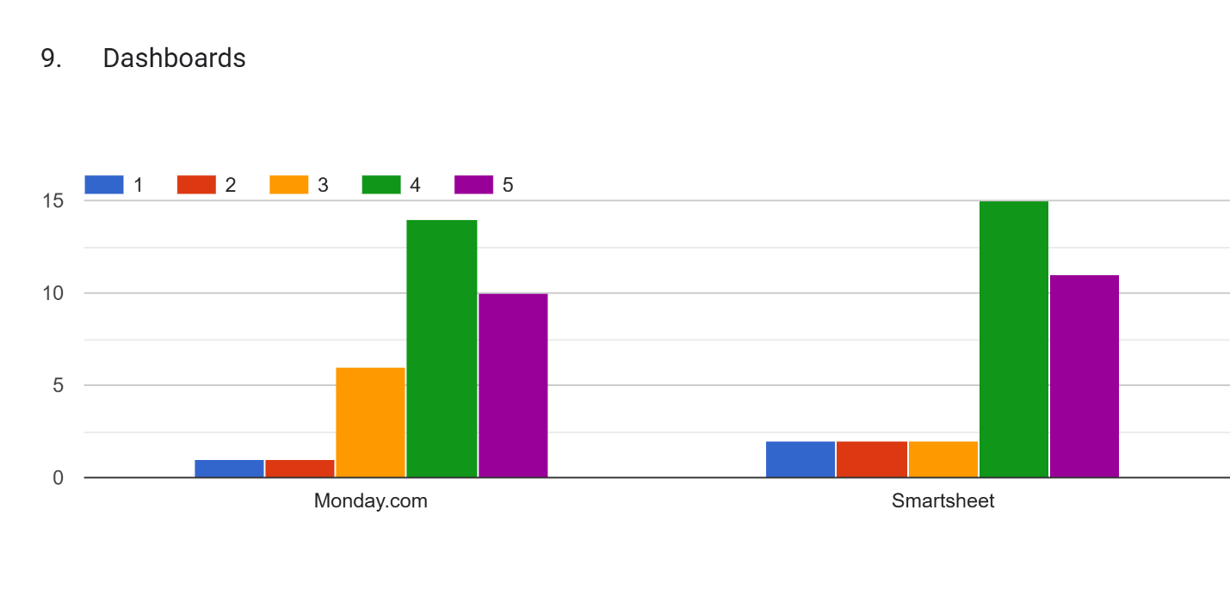

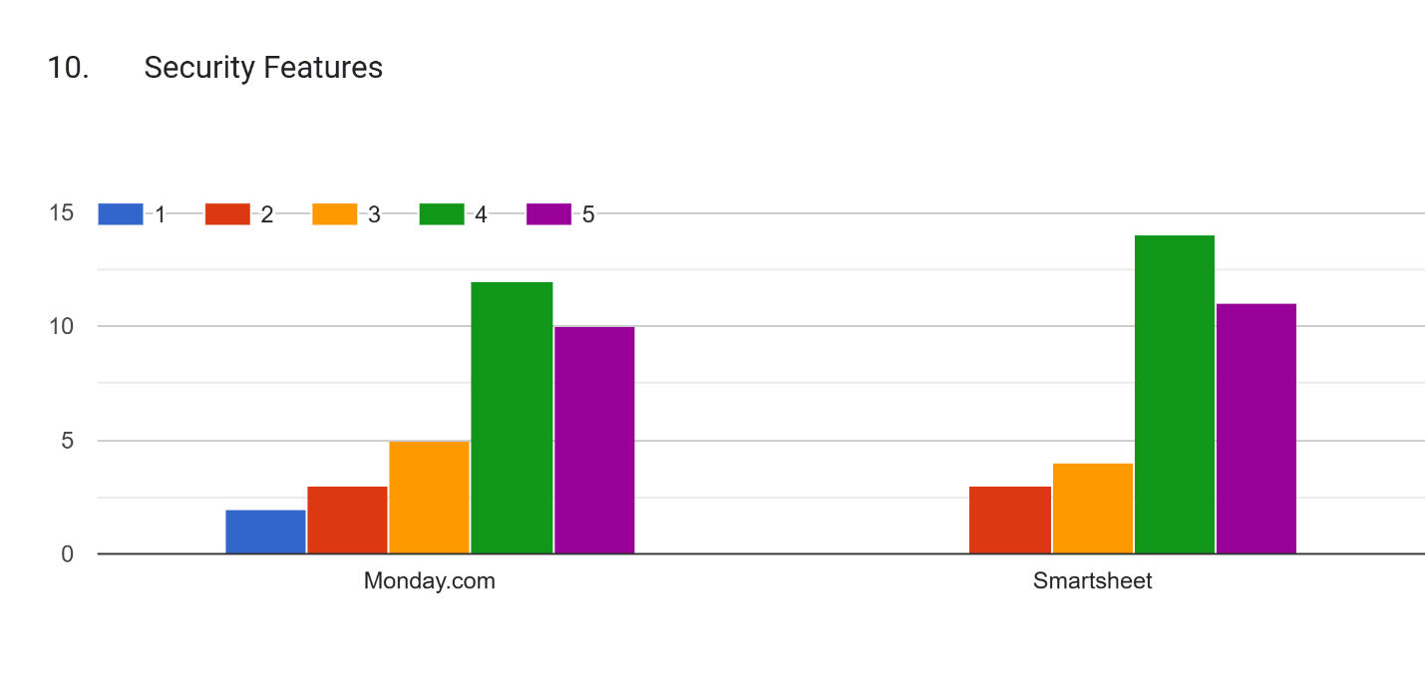

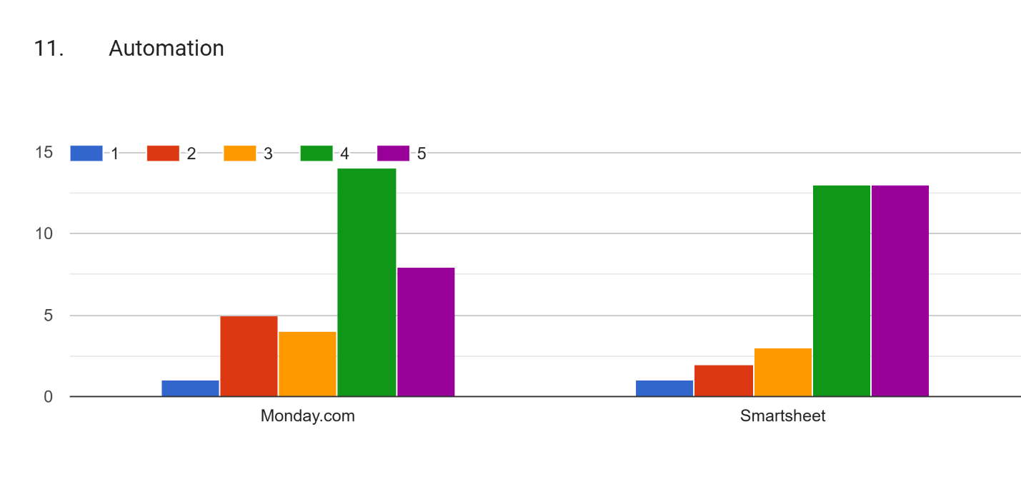

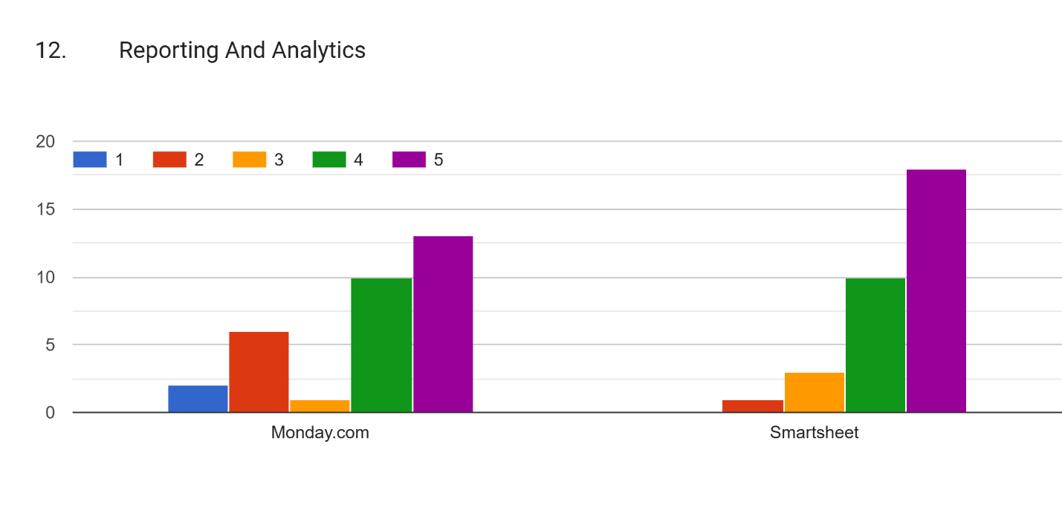



Forms response chart. Question title: 1. Easy-To-Use & User Friendliness:  The software is user friendly and easy to navigate around the interfaces 
. Number of responses: .

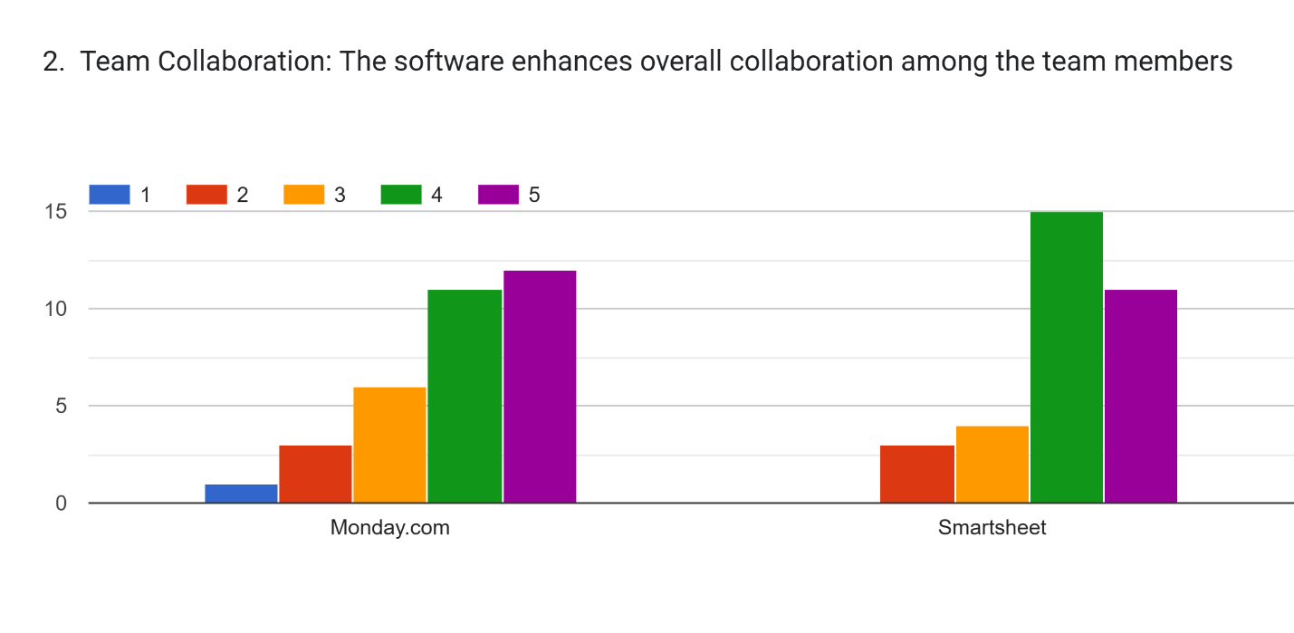

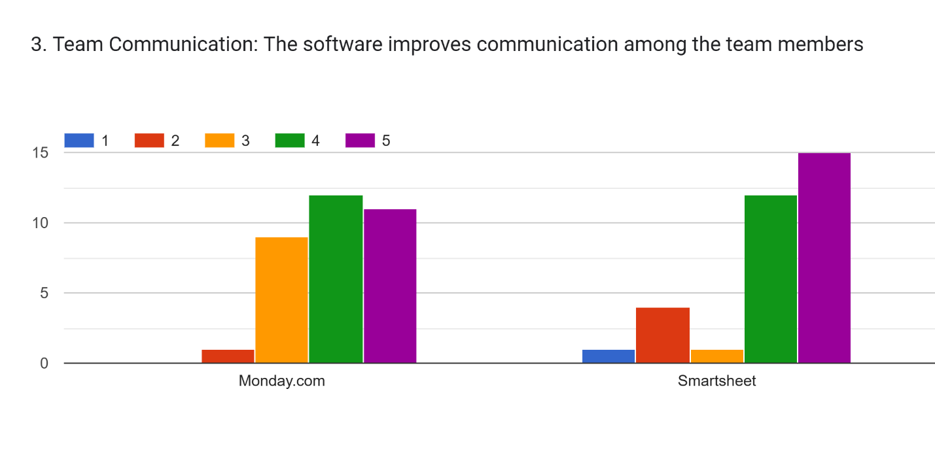

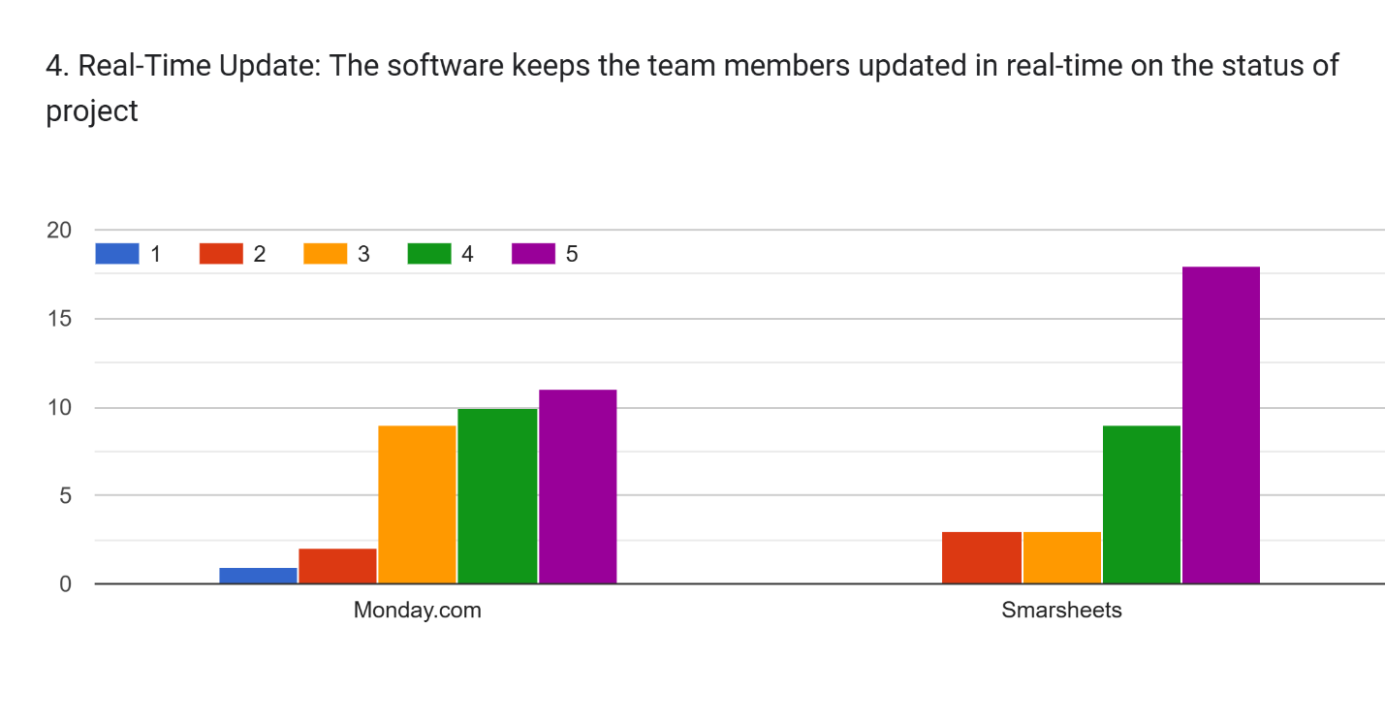

Forms response chart. Question title: 5. Project Management:  The software facilitates effective tracking of tasks 
. Number of responses: .

Forms response chart. Question title: 6. Tasks Time Tracking:  The software helps tracking of time spent on tasks and allow monitor progress
. Number of responses: .

Forms response chart. Question title: 7. Reporting & Insights:  Generates reports on project status, resource utilization and milestones
. Number of responses: .

